Emerging Leaders in the Americas Program (ELAP) 2026-2027
Application Form for *Research Candidates

*Please note: Research candidates may NOT take classes, as they are expected to work full-time (35 hours per week) on their research projects. This option is best suited for Graduate students who are working on their thesis dissertation research, and whose home supervisor is already collaborating with a Lakehead professor. Well-prepared undergraduate students may apply for a research stay if there is a genuine ongoing research collaboration between their home university and Lakehead on which they can participate.

Candidates are encouraged to discuss with their home supervisor(s) before contacting a potential supervisor at Lakehead. Candidates are responsible for proposing their own research project and finding their own supervisor at Lakehead. ALL research applicants (undergraduate and graduate alike) are required to provide a Letter of Invitation from a Lakehead supervisor.

For assistance with research applications, please contact Jill Sherman at intl.research@lakeheadu.ca.

To be eligible, candidates must be:
- Citizens of the following eligible countries/territories:
  - Caribbean: Anguilla, Antigua and Barbuda, Bahamas, Barbados, Belize, Bermuda, British Virgin Islands, Cayman Islands, Cuba, Dominica, Dominican Republic, Grenada, Guyana, Haiti, Jamaica, Montserrat, Saint Kitts and Nevis, Saint Lucia, Saint Vincent and the Grenadines, Suriname, Trinidad and Tobago, Turks and Caicos;
  - Central America: Costa Rica, El Salvador, Guatemala, Honduras, Nicaragua, Panama;
  - North America: Mexico;
  - South America: Argentina, Bolivia, Brazil, Chile, Colombia, Ecuador, Paraguay, Peru, Uruguay, Venezuela.
- Enrolled full-time at a post-secondary institution in an eligible country/territory;
- Paying tuition fees to that institution at the time of application and for the full duration of their mobility in Canada;
- Able to arrive no sooner than August 1, 2026 and no later than March 1, 2027.

Scholarships may not be awarded to individuals who:
- Hold or have a pending application for Canadian citizenship or permanent residency.
- Are already holding another grant or source of funding from Global Affairs Canada (GAC), through its legal name, the Department of Foreign Affairs, Trade and Development (DFATD), or from a Canadian federal granting agency (e.g. Natural Sciences and Engineering Research Council of Canada (NSERC), Social Sciences and Humanities Research Council (SSHRC) or Canadian Institutes of Health Research (CIHR). All additional sources of funding must be declared.
- Are already enrolled in a degree, diploma or certificate program at a Canadian post-secondary institution.
- Submit or have submitted an application for the same scholarship to any other institution in Canada.

CONTINUE TO THE NEXT PAGE TO FILL OUT THE APPLICATION
Please type your answers in each of the yellow-highlighted sections below. You will see selection options (pictured in grey) for some fields that you must choose from for those sections.
IMPORTANT: The complete application must be in Word (.docx) format.

- CANDIDATE INFORMATION
- Prefix/Salutation (Mandatory): ______
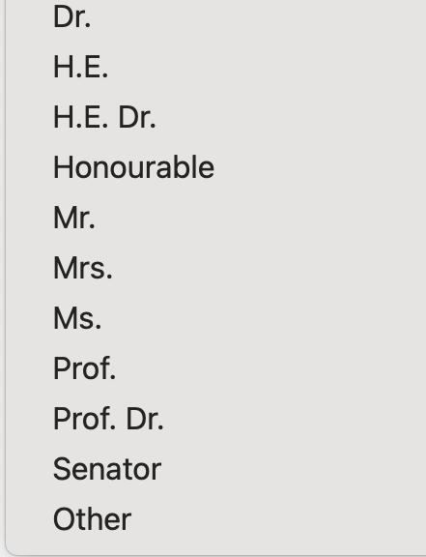
- First Name as shown on passport (Mandatory): ______
- Last Name as shown on passport (Mandatory): ______
- Gender (Mandatory): ______
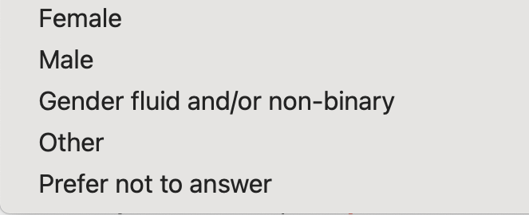
- Date of birth (dd/mm/yyyy) (Mandatory): ______
- Email (Mandatory): ______
- Country of citizenship (Mandatory): ______
- Degree sought at the home institution (Mandatory): ______

- Field of Study (Mandatory): ______


- Discipline (Mandatory) Select from the options below: ______
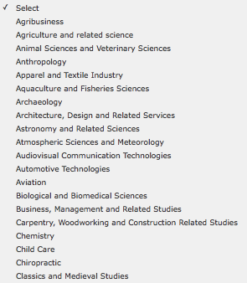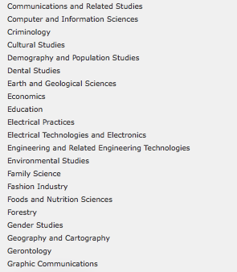
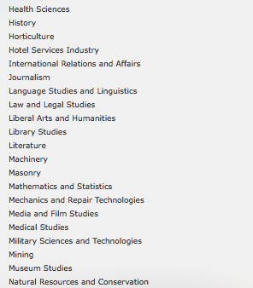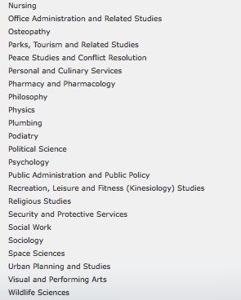
- Expected Completion Date of Degree (mm/yyyy) (Mandatory): ______

- INTENDED SCHOLARSHIP INFORMATION
- Select the scholarship component (Must select only ONE option with “X”) (Mandatory):
  - College/Undergraduate - 4 months or 1 academic term: ______
  - Graduate - 4 months or 1 academic term: ______
  - Graduate - 5 to 6 months: ______
- Expected scholarship start date between 01 August 2026 and 01 February 2027 (in the format of dd/mm/yyyy) (Mandatory): ______
- Expected end date of the scholarship (in the format of dd/mm/yyyy) (Mandatory): ______

Important information for start and end dates: Research candidates are strongly encouraged (but not required) to align their dates of stay with our semester dates, because:
- On-campus housing may only be available for full-semester bookings. We do not guarantee on-campus housing.
- Students who arrive at the start of a semester can take advantage of new student orientations.

For Fall 2026 semester (4 month stay), recommended start and end dates are 01/09/2026 to 31/12/2026.
For Winter 2027 semester (4 month stay), recommended start and end dates are 01/01/2027 to 30/04/2027.
For 5 to 6 month stay candidates, the start date is recommended to align with the start of either semester.

- Type of exchange activity the candidate will undertake at the Canadian institution: Research
- Language of study at the Canadian institution: English

- CANDIDATE’S HOME POSTSECONDARY INSTITUTION
- Institution Name in English (Mandatory): ______ (No short forms nor abbreviations will be accepted.)
- Address (Mandatory): ______
- City/Town (Mandatory): ______
- Province/Territory/State (Mandatory): ______ (No short forms or abbreviations)
- Postal/ZIP code (Mandatory): ______
- Country (Mandatory): ______

- CONTACT PERSON RESPONSIBLE FOR THE EMERGING LEADERS IN THE AMERICAS PROGRAM (ELAP) AT THE CANDIDATE’S HOME INSTITUTION
- Full Name (Mandatory): ______
- Job Title (Mandatory): ______
- Department/Office (Mandatory): ______
- Phone (Mandatory: Country Code + Phone #): ______
- Email (Mandatory): ______

- CANADIAN (Lakehead University) ACADEMIC SUPERVISOR INFORMATION:
- Full Name (Mandatory): ______
- Job Title (Mandatory): ______
- Department/Office (Mandatory): ______
- Email (Mandatory): ______
- Lakehead Campus location for your supervisor (Mark “X” to Select)”
  - Thunder Bay ___
  - Orillia ___
  - Barrie ___

ELAP Documents to Submit - For Research Candidates

You must submit all of the following documents. All documents must be in English.

- Completed Research ELAP 2026/2027 Application Form (pages 1-4 above) in Word (.docx) format only.

- Proof of citizenship:
  - a copy of the candidate's passport (highly recommended for submission) or national identity card with a photo and valid dates
  - documents not accepted as proof of citizenship are: driver’s license, permanent residence card, work permit, student card, health card, birth certificate or baptismal certificate
  - proof of citizenship must be from the same country/territory as the citizenship stated in the above application form

Sample | 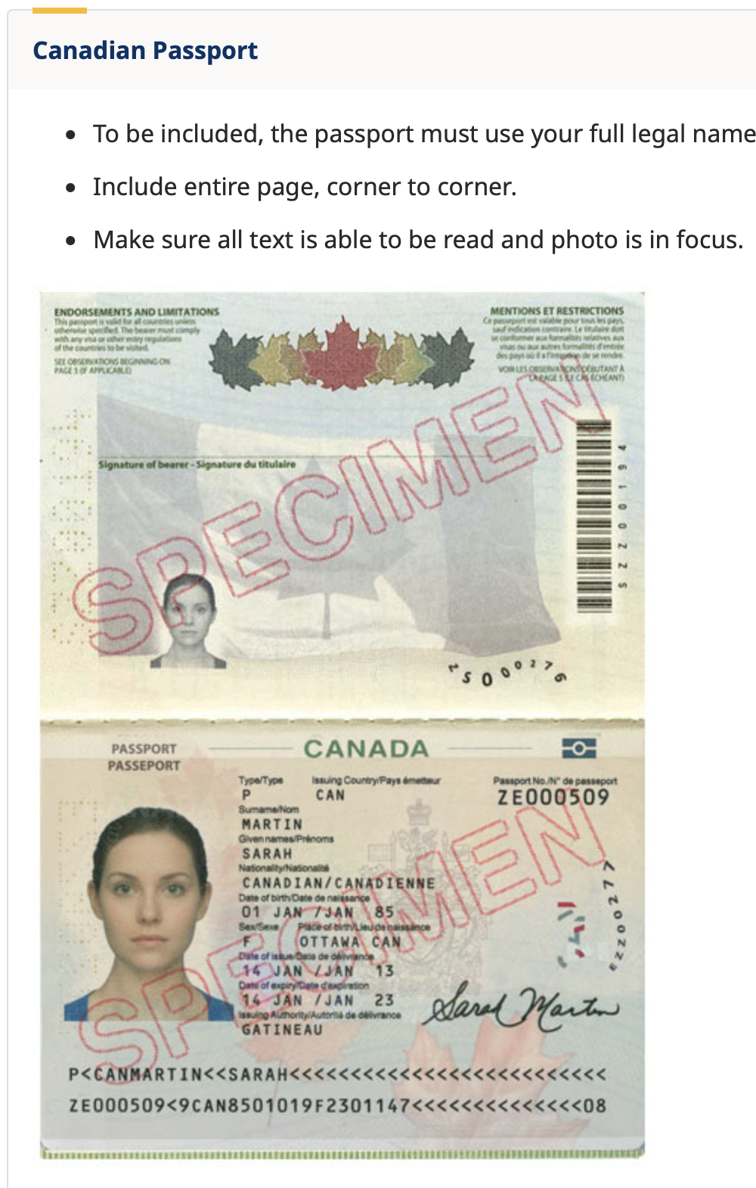

- Letter/Certificate of proof of full-time enrolment from the home institution (in English, or accompanied by an English translation)
  - on official letterhead
  - dated within the last three months
  - confirms that the candidate is currently enrolled in a full-time program (letters must contain the words FULL TIME, or else the application will be considered incomplete)
  - Note: copies of transcripts, a student card or a letter of admission are not acceptable substitutes.

- Letter of intent from the candidate (maximum two pages) (in English)
  - Provides rationale for participating in an international research stay
  - Rationale for choosing Lakehead and/or their host supervisor
  - Research plan (questions, objectives, activities, time line, expected outcomes)
  - How the proposed research project will support their future career goals.

- Letter of support from the home institution (maximum one page) (in English)
  - Written by the candidate's home supervisor or other professor;
  - Prepared on official letterhead, signed, and dated within the last three months;
  - Describes how the planned research mobility fits within the student’s academic program
  - Describes the student’s preparedness to undertake the proposed research stay;
  - Discusses how the candidate and the home institution will benefit from this research collaboration.

- Letter of invitation from the host (Lakehead) supervisor (maximum two pages) (in English)
  - Prepared on official letterhead, signed, and dated within the last three months
  - Describes the nature and scope of the research collaboration with the candidate’s home institution
  - Briefly summarizes the research plan/project and any special facilities / equipment / expertise at Lakehead that is required to complete the project
  - Confirms their willingness to support and mentor the candidate during the exchange period
  - Describes the benefits of the research stay to the project, the department, and/or to Lakehead

- Candidate’s most recent academic transcript (in English, or accompanied by an English translation). The transcript may be an unofficial version, so long as the coordinator submitting the nomination confirms its accuracy and authenticity.

- Signed & Dated Applicant Attestation Form. This document is attached to the call for nominations email and attests to the eligibility of the candidate.

- Signed & Dated Privacy Notice Statement: a copy of the Privacy Notice Statement for non-Canadian participants signed by the candidate and dated within the last six months (this document is also attached to this email)

