Emerging Leaders in the Americas Program (ELAP) 2026-2027
Application Form for Study Candidates

To be eligible, candidates must be:
- Citizens of the following eligible countries/territories:
  - Caribbean: Anguilla, Antigua and Barbuda, Bahamas, Barbados, Belize, Bermuda, British Virgin Islands, Cayman Islands, Cuba, Dominica, Dominican Republic, Grenada, Guyana, Haiti, Jamaica, Montserrat, Saint Kitts and Nevis, Saint Lucia, Saint Vincent and the Grenadines, Suriname, Trinidad and Tobago, Turks and Caicos;
  - Central America: Costa Rica, El Salvador, Guatemala, Honduras, Nicaragua, Panama;
  - North America: Mexico;
  - South America: Argentina, Bolivia, Brazil, Chile, Colombia, Ecuador, Paraguay, Peru, Uruguay, Venezuela.
- Enrolled full-time at a post-secondary institution in an eligible country/territory;
- Paying tuition fees to that institution at the time of application and for the full duration of their mobility in Canada;
- Able to arrive no sooner than August 1, 2026 and no later than February 1, 2027.

Scholarships may not be awarded to individuals who:
- Hold or have a pending application for Canadian citizenship or permanent residency.
- Are already holding another grant or source of funding from Global Affairs Canada (GAC), through its legal name, the Department of Foreign Affairs, Trade and Development (DFATD), or from a Canadian federal granting agency (e.g. Natural Sciences and Engineering Research Council of Canada (NSERC), Social Sciences and Humanities Research Council (SSHRC) or Canadian Institutes of Health Research (CIHR). All additional sources of funding must be declared.
- Are already enrolled in a degree, diploma or certificate program at a Canadian post-secondary institution.
- Submit or have submitted an application for the same scholarship to any other institution in Canada.

CONTINUE TO THE NEXT PAGE TO FILL OUT THE APPLICATION

Please type your answers in each of the yellow-highlighted sections below. You will see selection options (pictured in grey) for some fields that you must choose from for those sections.
IMPORTANT: The complete application must be in Word (.docx) format.

- CANDIDATE INFORMATION
- Prefix/Salutation (Mandatory): ______
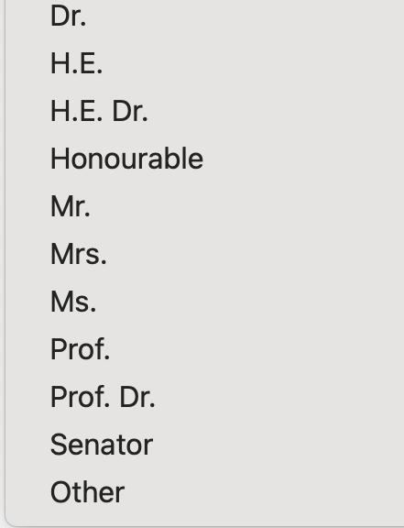
- First Name as shown on passport (Mandatory): ______
- Last Name as shown on passport (Mandatory): ______
- Gender (Mandatory): ______
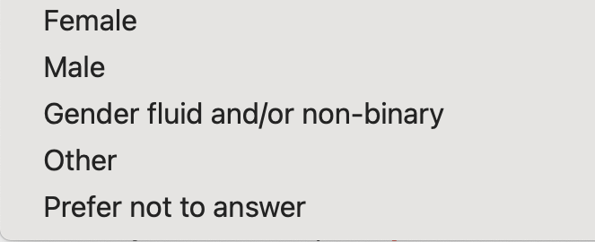
- Date of birth (dd/mm/yyyy) (Mandatory): ______
- Email (Mandatory): ______
- Country of citizenship (Mandatory): ______
- Degree sought at the home institution (Mandatory): ______

- Field of Study (Mandatory): ______


- Discipline (Mandatory) Select from the options below: ______


- Expected Completion Date of Degree (mm/yyyy) (Mandatory): ______

- INTENDED SCHOLARSHIP INFORMATION
- Select the scholarship component (Must select only ONE option with “X”) (Mandatory):
  - College/Undergraduate - 4 months or 1 academic term: ______
  - *Graduate - 4 months or 1 academic term: ______
*Please note: Graduate students coming on a study scholarship may only enrol in undergraduate-level classes at Lakehead University. Please browse upper-year courses to determine your interest in pursuing this option.

- Expected scholarship start date between 01 August 2026 and 01 February 2027 (in the format of dd/mm/yyyy) (Mandatory): ______
- Expected end date of the scholarship (in the format of dd/mm/yyyy) (Mandatory): ______

Important information for start and end dates: Study candidates must select dates that align with either our fall or winter semester. For Fall 2026 semester selection, input a start date of 01/09/2026 and an end date of 31/12/2026. For Winter 2027 semester selection, input a start date of 01/01/2027 and an end date of 30/04/2027.

- Type of exchange activity the candidate will undertake at the Canadian institution: Study
- Language of study at the Canadian institution: English

- CANDIDATE’S HOME POSTSECONDARY INSTITUTION
- Institution Name in English (Mandatory): ______ (No short forms nor abbreviations will be accepted.)
- Address (Mandatory): ______
- City/Town (Mandatory): ______
- Province/Territory/State (Mandatory): ______ (No short forms or abbreviations)
- Postal/ZIP code (Mandatory): ______
- Country (Mandatory): ______

- CONTACT PERSON RESPONSIBLE FOR THE EMERGING LEADERS IN THE AMERICAS PROGRAM (ELAP) AT THE CANDIDATE’S HOME INSTITUTION
- Full Name (Mandatory): ______
- Job Title (Mandatory): ______
- Department/Office (Mandatory): ______
- Phone (Mandatory: Country Code + Phone #): ______
- Email (Mandatory): ______

- LIST OF COURSES FOR STUDY AT LAKEHEAD UNIVERSITY:
- Provide a list of 3-5 undergraduate level Lakehead courses to be undertaken. (Mandatory): ___________________________________________________________________________________
Candidates can reference our timetable from our current 2025/2026 academic year when looking for courses to take. The timetable for the 2026/2027 academic year will not be available until approximately June 2026. However, most courses will be available again, so the current timetable will give an idea of what may be available for study. The student will need to choose the program they are interested in (example: Business), and then it will list the courses available. Please note that these courses can be changed during the future course registration process. Please reference the Academic Timetable for the course codes and names. NOTE - Students are not eligible to take courses in the following departments: Nursing, Social Work, Education, Law and Medicine.
- Lakehead Campus location for your study semester (Mark “X” to Select) (Mandatory):
  - Thunder Bay ___
  - Orillia ___

ELAP Documents to Submit - For Study Candidates

You must submit all of the following documents. All documents must be in English or accompanied by an English translation.

- Completed Study ELAP 2026/2027 Application Form (pages 1-4 above) in Word (.docx) format only.

- Proof of citizenship:
  - a copy of the candidate's passport (highly recommended for submission) or national identity card with a photo and valid dates
  - documents not accepted as proof of citizenship are: driver’s license, permanent residence card, work permit, student card, health card, birth certificate or baptismal certificate
  - proof of citizenship must be from the same country/territory as the citizenship stated in the above application form

Sample | 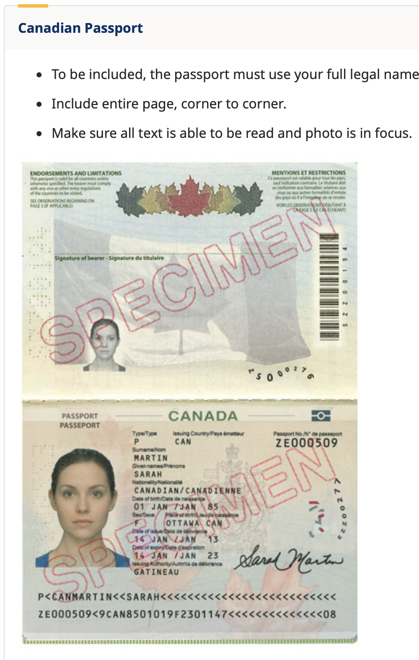

- Letter of proof of full-time enrolment from the home institution (in English, or accompanied by an English translation)
  - on official letterhead
  - dated within the last three months
  - confirms that the candidate is currently enrolled in a full-time program (letters must contain the words FULL TIME, or else the application will be considered incomplete)
  - Note: copies of transcripts, a student card or a letter of admission are not acceptable substitutes.

- Letter of intent from the candidate (maximum two pages) that clearly and concisely addresses the following (in English)
  - Question 1:Please provide your rationale for studying in Canada and for choosing Lakehead University as the host institution, including the selected academic program, and explain how the proposed program of study relates to your future academic and/or career goals.
  - Question 2: How do you define “leadership,” and how have your previous academic, professional, or extracurricular experiences shaped that definition?

- Letter of support from the home institution (maximum one page) (in English)
  - Written on the official home institution’s letterhead
  - dated within the last three months
  - Acceptable only the letter is issued by the candidate’s instructor or professor who has previously engaged with the candidate in an academic capacity
  - Explain the nature of the study to be undertaken in Canada and how the candidate and their
their home institution will benefit from the scholarship
Key factors for a strong support letter include:
  - A personalized assessment of the candidate (template letters are strongly discouraged)
  - Clear explanation of how the ELAP scholarship will impact the candidate’s future studies and long-term goals
  - Identification of the academic, institutional, or strategic benefits to the home institution resulting from the student’s participation in the program

- Candidate’s most recent academic transcript (in English, or accompanied by an English translation). The transcript may be an unofficial version, so long as the coordinator submitting the nomination confirms its accuracy and authenticity.

- Signed & Dated Applicant Attestation Form. This document is attached to the call for nominations email and attests to the eligibility of the candidate.

- Signed & Dated Privacy Notice Statement: a copy of the Privacy Notice Statement for non-Canadian participants signed by the candidate and dated within the last six months (this document is also attached to this email)

